TUNING THE GUITAR
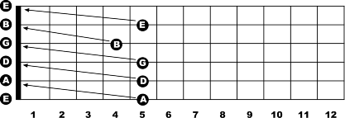

- Play the note at the 6th string, 5th fret. Now play the 5th string with no fingers. Listen closely to see if the pitch of the 5th string is higher or lower than the one you are holding at the 5th fret, 6th string. If the 5th string is lower, turn the tuning key for the 5th string to raise the pitch until it matches the pitch of the note you are holding at the 6th string, 5th fret. If the 5th string is higher, lower the pitch of the 5th string until it matches the note you are fretting on the 6th string.
- The rest of the way is just a repeat of what you have already done. After the 5th string is in tune, hold down the 5th string at the 5th fret to tune the 4th string. Hold the 4th string, 5th fret to tune the 3rd string.
- This pattern only changes on the 3rd string. Hold the 3rd string at the 4th fret to tune the 2nd string.
- Hold the 2nd string, 5th fret to tune the 1st string.
Congratulations. Your guitar is now in tune.

Here’s a tip.
When you tune a guitar, you always want to tune up to the note. This way, you are tightening the string around the post of the tuning peg. This helps the guitar stay in tune better. If you lower a string into pitch, then it can slip causing the guitar to go out of tune again.

